Design of thermal systems

Group 23

Abstract - Ice Skating Rink

The topic that our team will be looking at is the design of an indoor, artificial ice skating rink. This system will be based on a reverse Rankine cycle (refrigeration cycle). Our goal in this project is twofold: to minimize the amount of power needed in order to maintain the system under conditions defined by our boundary conditions and assumptions, as well as to minimize the overall environmental impact.

As this is an open-ended design project, we begin by making numerous assumptions. The most basic of these have to do with the dimensions of the ice skating rink; we will assume a typical rink with dimensions 30m by 60m and ice thickness of 0.01905m. These dimensions are approximately the size of an official NHL hockey ice rink. We also assume that the ambient indoor air temperature above the rink is a compromise between human comfort and rink efficiency at 10˚C. This temperature is provided by either a separate air conditioning or heating system (depending on external temperatures) with which we will not concern ourselves. Additionally, we make assumptions about the thermodynamic cycle itself; an indirect system will be used in which the working fluids of choice are freon, as the primary fluid and brine, as the secondary fluid.

The indirect system used for the ice skating rink operates by using an ice plant and condensers for the primary fluid and the secondary fluid then circulates between the ice plant and the ice rink floor. The ice plant and condensers are a refrigeration cycle that cools the primary fluid and receives heat from the secondary fluid in the evaporator. The now heated primary fluid has its heat removed in the condenser. The secondary fluid flows through a series of pipes in the chilled concrete underneath the rink floor, keeping the ice frozen. We will take into account friction from the pipes throughout the whole process. The process will be designed something like fig. 1 shown on the next page.

To optimize for the lowest possible net energy consumption, we plan to vary the operating temperatures and pressures within the reverse Rankine cycle. Given our choices of working fluids, we will be bound in our choices by the operating parameters of these fluids. We also plan to optimize for minimal environmental impact. We aim to limit Nitrogen Dioxide emissions to 100 ppb and groundwater flow to 60,000 gallons per year. Enforcing these constraints will also limit the possible operating parameters of the overall system. We also aim to analyze and limit the costs associated with running the thermal system.

Assumptions:

* indoor rink so the temperature of the air is about 10˚C and the temperature of the ice would be kept at -4˚C.
* Dimensions of the rink are 30 m by 60 m (about the size of an official NHL rink) and have an ice thickness of about 0.01905 m.
* The liquid coolant used in the refrigeration system is brine water
* Raw materials: deionized water, chilled concrete, sand, and glass
* Heat sensors are used below the ice to keep track of the temperature.
* R-717 freon is being used
* Environmental impact:

1. 60,000 gallons of water (enough drinking water for 2,000 families of 4 for an entire month
2. NO2 gas: emitted from different components of an ice rink like the resurfacing machine (Zamboni). World means shows each rink has safe levels of 228ppb while 100 is the safety standard.

* Cost impact: monthly power rate of $13.71/kW and consumption rate of $0.0449/kWh

Since Ice Rinks don’t necessarily expire, not really polluting in terms of physical objects.

* Roughly 1300 GWh/year.

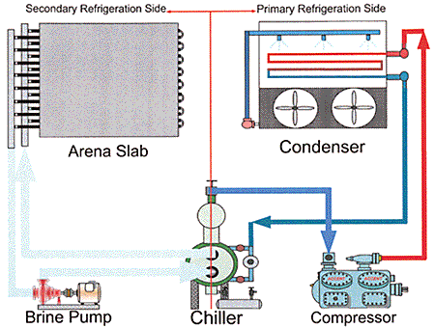

**Fig. 1** Indirect cooling system

References:

<https://www.usicerinks.com/application/files/2315/1370/1689/Refrigeration_101_Series_-_2010.pdf>

diva-portal.org/smash/get/diva2:478941/fulltext01

<https://en.wikipedia.org/wiki/Ice_rink>

<https://bshockey.com/hockey-game-temperature/>

<https://www.achrnews.com/articles/85016-recreational-refrigeration-skating-on-thick-ice>